1. What is the difference between compilation and translation🡺

* **Compilation** is transforming code in a higher-level language to a lower-level one. Examples: Java to Java Bytecode, or C to x86 machine code.
* **Decompilation** is transforming a code in a lower-level language to a higher-level one - in effect, the opposite of compilation. Examples: Java Bytecode to Java.
* **Translation** or **source-to-source compilation** is transforming a code in some language to another language of comparable "level". Examples: ARM to x86, or C to Java. When the two languages are actually different versions of the same language (e.g. Javascript 6 to Javascript 5), the term **transpiler** is also used.

1. Needed more information on the **yield** operator of JS
2. Needed more information on the for-in loop of js
3. Practical idea is needed on how to add a method on to the object
4. JavaScript String Methods 🡺

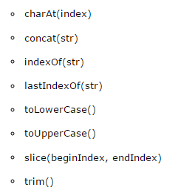

1. Needed example on “nan”